**Calculator Assumed**

**Topic: Arc Length and Sector Areas**

Time: 45 minutes

Total Marks: 45

Your Score: / 45



**Question One: [2, 3, 3 = 8 marks]**

Calculate the perimeter of each of the following shapes, giving your answers as exact values.



1. 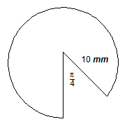



**Question Two: [5 marks]**

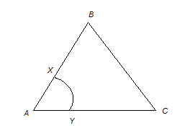The triangle shown is an equilateral triangle of side length 8 cm, with an arc XY with centre A.

AX:XB is in the ratio 1:3

AY:YC is in the ratio 1:3

Calculate the area of the section enclosed by XBCY.

**Question Three: [3 marks]**

A sector has a perimeter of .

Determine the angle at the centre of the arc if the radius is 6 cm.

**Question Four: [4 marks]**

The following image shows four quarter-circle arcs joined together. Each arc has a radius of 7 cm.

Calculate the area of the shape pictured.

**Question Five: [2, 1 = 3 marks]**

If the arc length of a sector with a central angle of 1 radian is 4 cm, determine:

1. the radius of the sector.
2. the perimeter of the sector.

**Question Six: [2, 2, 3, 3 = 10 marks]**

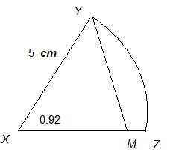The figure shown is such that 

The angle at the center of the sector,  , is 0.92 radians.

Calculate:

1. The length of arc YZ.
2. The area of the sector XYZ.
3. The length, XM.
4. The area of YMZ.

**Question Seven: [4, 1, 2, 3, 2 = 12 marks]**



The given diagram shows the design for a student classroom desk.

Calculate:

1. the area of the triangular section.
2. the angle at the centre of the sector, in radians.
3. the length of the arc.
4. the area of the segment.
5. the perimeter when three desks have been joined together.

**SOLUTIONS**

**Calculator Assumed**

**Topic: Arc Length and Sector Areas**

Time: 45 minutes

Total Marks: 45

Your Score: / 45



**Question One: [2, 3, 3 = 8 marks]**

Calculate the perimeter of each of the following shapes, giving your answers as exact values.





 

1. 











**Question Two: [5 marks]**

The triangle shown is an equilateral triangle of side length 8 cm, with an arc XY with centre A.



AX:XB is in the ratio 1:3

AY:YC is in the ratio 1:3

Calculate the area of the section enclosed by XBCY.







**Question Three: [3 marks]**

A sector has a perimeter of .

Determine the angle at the centre of the arc if the radius is 6 cm.



**Question Four: [4 marks]**

The following image shows four quarter-circle arcs joined together. Each arc has a radius of 7 cm.

Calculate the area of the shape pictured.





**Question Five: [2, 1 = 3 marks]**

If the arc length of a sector with a central angle of 1 radian is 4 cm, determine:

1. the radius of the sector.





1. the perimeter of the sector.





**Question Six: [2, 2, 3, 3 = 10 marks]**



The figure shown is such that 

The angle at the center of the sector,  , is 0.92 radians.

Calculate:

1. The length of arc YZ.





1. The area of the sector XYZ.



1. The length, XM.



1. The area of YMZ.





**Question Seven: [4, 1, 2, 3, 2 = 12 marks]**



The given diagram shows the design for a student classroom desk.

Calculate:

1. the area of the triangular section.



1. the angle at the centre of the sector, in radians.



1. the length of the arc.





1. the area of the segment.





1. the perimeter when three desks have been joined together.



